SECTION A
Answer ALL questions in this section.
Write your answers in the spaces provided in this booklet.
- Students of an ecology class conduct a field study in an area located on the boundary between a savannah and the forest. In addition to using various sampling methods to estimate species abundance, they observe the feeding patterns of the Organisms.

- (i) Describe TWO sampling methods which the students could use to estimate the abundance of plant species in the area. (4 mks)

(ii) Describe ONE method they could use to collect data on mobile animals which
Inhibit the area. (2 mks)

- The students record their data in a table similar to table 1.
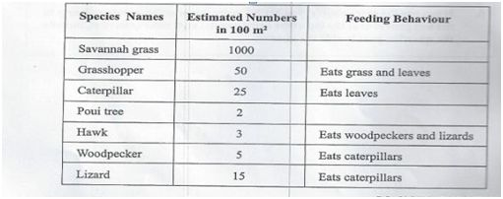
TABLE 1: DATA ON ORGANISMS IN THE FIELD STUDY

Use the data from table 1 to construct EACH of the following:
- A food web (4 mks)
- A pyramid of numbers to show the feeding relationships among the organisms living in the area. (2 mks)

- The students also collected samples of topsoil from an area under some trees.
- Describe an experiment that the students can use to investigate the water-holding capacity of the soil. (3 mks)
- State FOUR ways in which soil is important to living organisms. (4 mks)

- Figure 1 shows the apparatus that the students used to extract small animals (invertebrates) living in the soil.

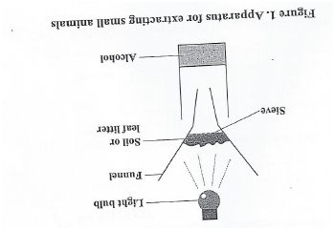
Outline how EACH of the following functions in the apparatus:
- Light bulb (2 mks)
- Alcohol (1 mk)

- Fungi and bacteria are found in forest soils. Explain the role of these organisms in the cycling of nutrients in the forest. (3 mks)

- (a) The following chemical equation for photosynthesis represents the reactants used and the products formed.
6CO2 + 6H20 C6H1206 + 602
(glucose)

- Name TWO conditions, which are not shown the equation , that are essential for this process. (2 mks)
- Name the gas given off in the process and state which of the reactants produced this gas.
Gas : ________________________
Reactant: _____________________ (2 mks)

- Explain TWO ways in which plants utilize the glucose produced during this process. (4 mks)

- State THREE environmental factors which affect photosynthesis. (3 mks)

(b) Unlike plants, animals are unable to synthesize glucose. A boy eats a meal of cassava.
Explain how his body converts the starch in the cassava to glucose. Name the organs
and the enzymes involved in this process. (4 mks)

- Figure two is a diagram of the female reproductive system.
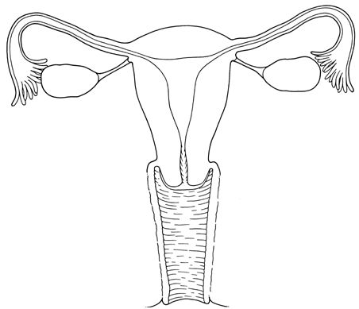
Figure 2. Structure of the human female reproductive system.

- Label the organs in Figure 2 to show where

- The female gametes (ova) are made (1 mk)

- Fertilization would occur (1 mk)

- Implantation of a fertilized gamete would normally occur (1 mk)

- Outline the mechanism by which male and female gametes come together in the human reproductive system to form a zygote. (3 mks)

- (i)Name the type of cell division by which female gametes are made. (1 mk)
(ii ) Describe TWO ways in which the type of cell division named in (c) (i) differs from that by which the embryo grows and develops after fertilization of an ovum. (4 mks)

- Embryonic stem cells are undifferentiated cells formed as the embryo grows and develops. These cells are capable of differentiating into specialised cells of tissues and organs in the human body.

- Suggest TWO reasons why cell specialization is important. (2 mks)

- Explain why embryonic stem cells can be used in the treatment of physiological diseases. (2 mks)

SECTION B
Answer ALL questions in this section.

- Albinism is seen in persons who are homozygous for recessive allele of a certain gene. This gene codes for the production of the skin pigment, melanin. Persons who inherit the dominant allele of this gene produce normal amount of melanin for their race.

- Distinguish between the following paired terms:
- Allele / Gene
- Dominant / Recessive
- Homozygous / Heterozygous
(6 mks)
- (i) Use a genetic diagram to show how a couple with normal pigmentation may produce an albino child. Use the following symbol to represent the alleles:
- Normal ; a- albino.
(4 mks)

(ii) Suggest TWO precautions that albino persons living in the Caribbean should take
When going outdoors. (2mks)
- Observation of the members of a population shows that there is variation in skin colour. Suggest THREE ways by which this type of variation could occur. ( 3 mks)

- The Central Nervous System coordinates the link between stimuli and responses.

- Make a labelled diagram of a horizontal section through the human eye and describe how the eye enables us to see. (6 mks)
- Discuss the effects of alcohol abuse on the human body’s ability to respond to stimuli and maintain homeostasis. (9 mks)

- (a) Name THREE characteristics which distinguish a biological species and THREE factors that lead to the formation of a new species. (6 mks)
(b) The distribution of variant forms of the peppered moth, Biston betularia, changed between
Pre-industrial and post-industrial Britain. Account the increase in nu,bers of the dark form in
the post-industrial era. ( 3 mks)

(c) Use the theory of natural selection to explain antibiotic resistance. (6 mks)

